Transferring Files between your laptop and Amazon instance[¶](http://angus.readthedocs.io/en/2014/amazon/transfer-files-between-instance.html" \l "transferring-files-between-your-laptop-and-amazon-instance" \o "Permalink to this headline)

For linux/Unix/Mac system, we can use a command-line tool “scp” to transfer files between your laptop and Amazon instance. Also we can use a GUI tool “FileZilla” to do the transfer, which is more user-friendly.

Using scp to transfer data

“scp” means “secure copy”, which can copy files between computers on a network. You can use this tool in a Terminal on a Unix/Linux/Mac system.

To upload a file from your laptop to Amazon instance:

$scp -i ~/Desktop/amazon.pem ~/Desktop/MS115.fa ubuntu@ec2-54-166-128-20.compute-1.amazonaws.com:~/data/

This command will upload a file - MS115.fa in your ~/Desktop/ folder of your laptop to folder ~/data/ on an Amazon instance. Note you still need to use the private key you used to connect to the Amazon instance with ssh. (In this example, it is the amazon.pem file in ~/Desktop/.

Note: You need to make sure that the user “ubuntu” has the permission to write in the target directory. In this example, if ~/data/ was created by user “ubuntu”, it should be fine.

Similarly, to download a file from Amazon instance to your laptop:

$scp -i ~/Desktop/amazon.pem ubuntu@ec2-54-166-128-20.compute-1.amazonaws.com:/data/ecoli_ref-5m-trim.fastq.gz ~/Download/

This command will download a file /data/ecoli_ref-5m-trim.fastq.gz from Amazon instance to your ~/Download folder in your laptop.

Note: You can use asterisk(*) to download multiple files, like [*](http://angus.readthedocs.io/en/2014/amazon/transfer-files-between-instance.html#id1).fasta.gz.

Using FileZilla to transfer data

If you want a more user-friendly tool to transfer data, FileZilla is a good choice. It is free, it supports Windows/Linux/Mac systems, and it has a good user interface. It supports FTP, SFTP and other file transfer protocols.

Firstly, go to ‘<https://filezilla-project.org/>‘ and click “Download FileZilla Client” button to download it.

The interface of FileZilla is like this:

[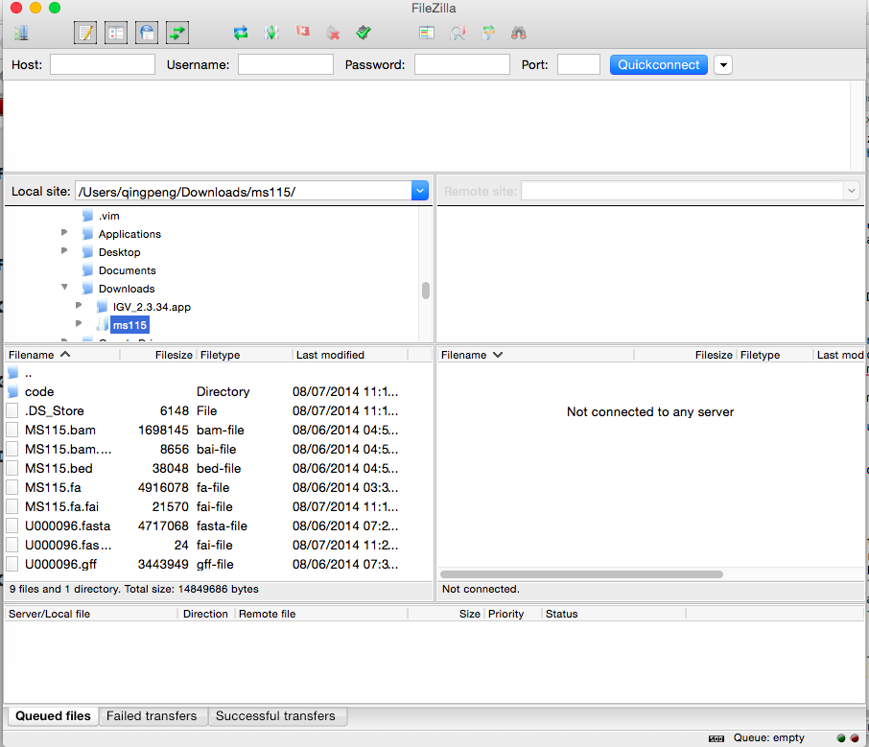](http://angus.readthedocs.io/en/2014/_images/filezilla_interface.png)

If you want to use FileZila to upload to or download data from a normal FTP server if you have the user and password, just put the information in the “Host”, “Username”, “Password” box and connect. However for Amazon instance, we use key-pair to log in instead of password for better safety. So it is a little bit more complicated to configure.

Open “Settings” and click “SFTP”:

[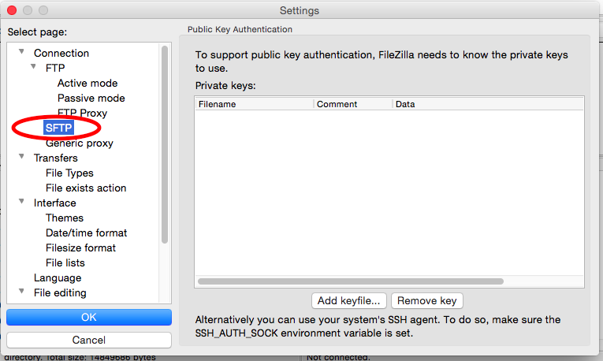](http://angus.readthedocs.io/en/2014/_images/filezilla_sftp.png)

Click “Add keyfile...”:

[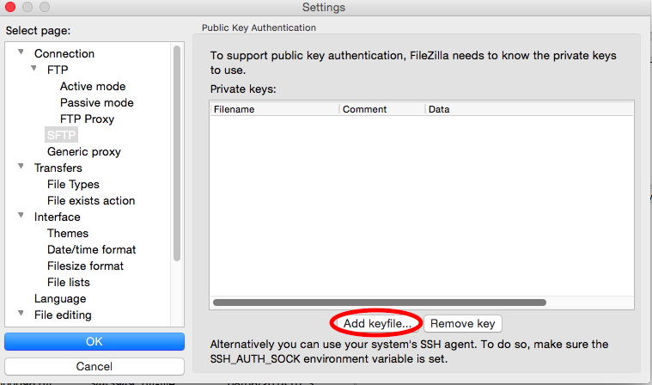](http://angus.readthedocs.io/en/2014/_images/add_keyfile.png)

Then select the ”.pem” file you used to connect to Amazon instance with ssh.

[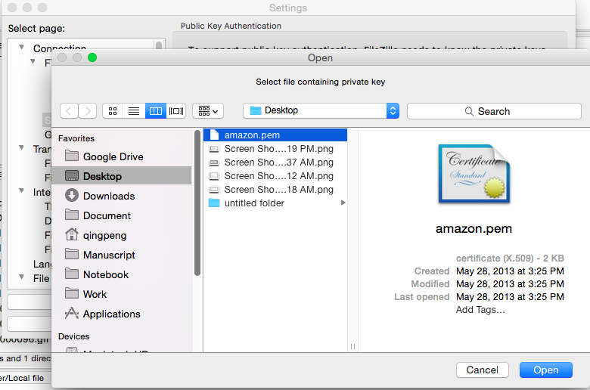](http://angus.readthedocs.io/en/2014/_images/select_pem.png)

There is a dialog box to ask you if you want to convert the ”.pem” file into a supported format. Click “Yes”.

[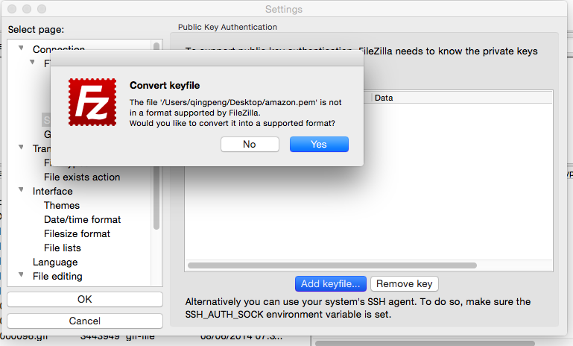](http://angus.readthedocs.io/en/2014/_images/convert_pem.png)

Name it with extension as ”.ppk” and save it.

[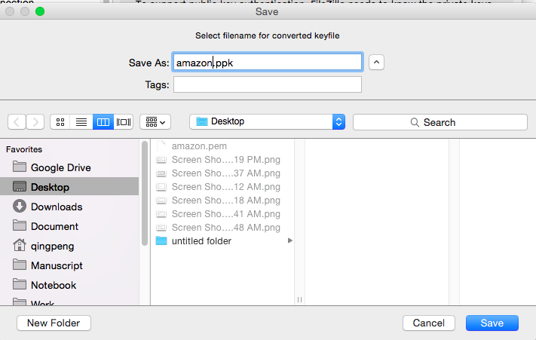](http://angus.readthedocs.io/en/2014/_images/save_ppk.png)

You will see the a private key has been added.

[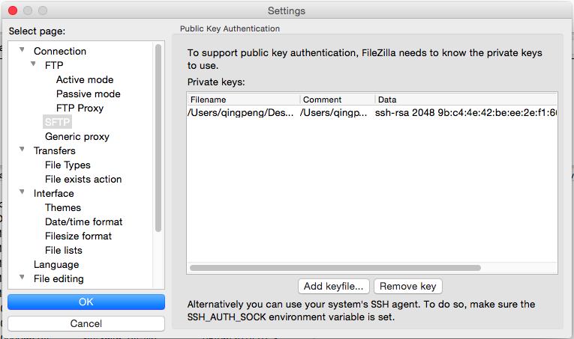](http://angus.readthedocs.io/en/2014/_images/show_key.png)

Close “Settings” and go back to the main interface.

Click button to open the site manager.

[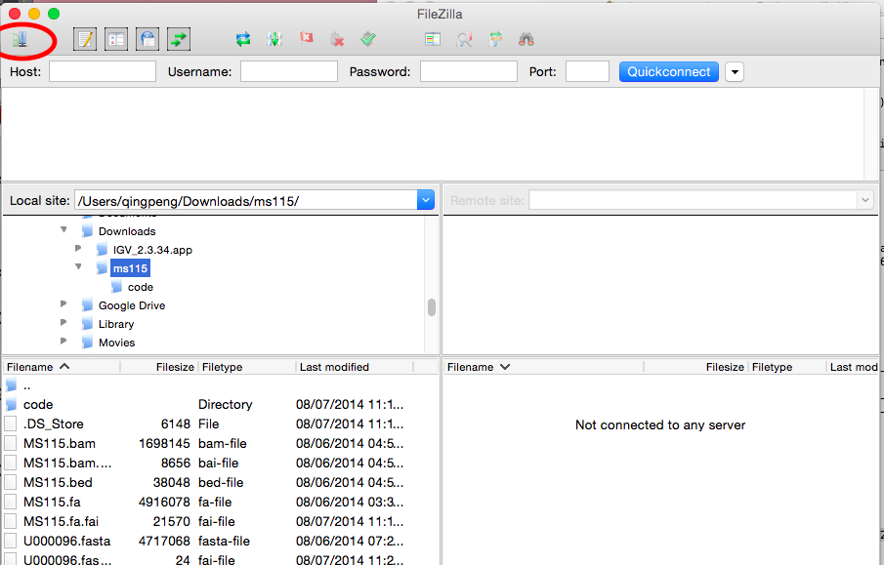](http://angus.readthedocs.io/en/2014/_images/site_manager.png)

Click “New Site”.

[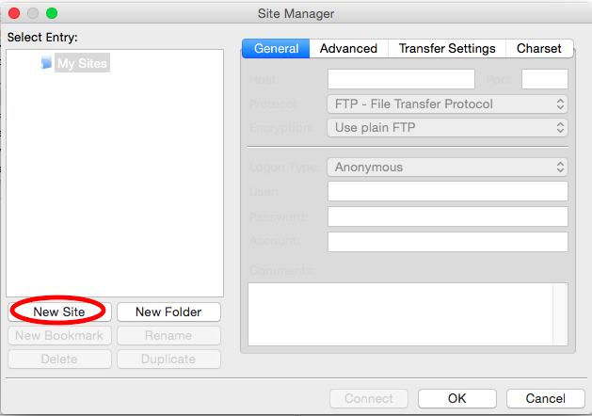](http://angus.readthedocs.io/en/2014/_images/new_site.png)

Put the Amazon instance URL like ec2-54-166-128-20.compute-1.amazonaws.com in the “Host” box. Set “Protocol” as “SFTP”, “Logon Type” as “Normal”, “User” as “ubuntu” and leave “Password” as blank. Then click “Connect”.

[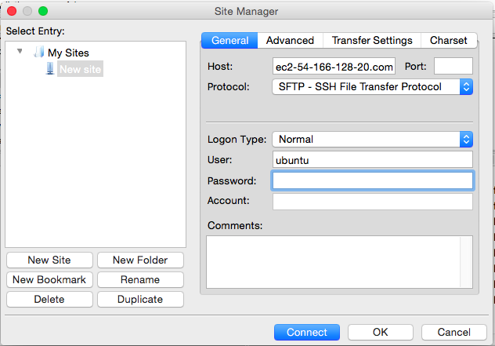](http://angus.readthedocs.io/en/2014/_images/site_config.png)

There will be a dialogue box to ask you about “Unknown host key”, just click “Ok”.

[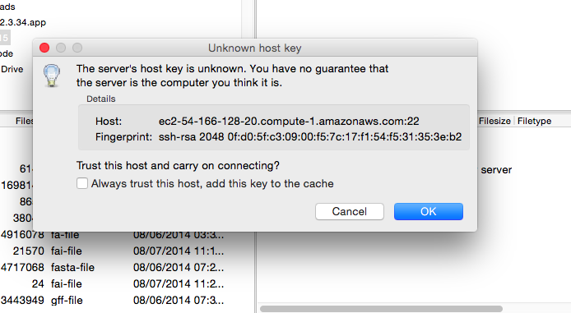](http://angus.readthedocs.io/en/2014/_images/host_key_diag.png)

All right. Now you have logged in the Amazon instance. You can drag and drop to transfer the files between the remote machine and your local laptop.

[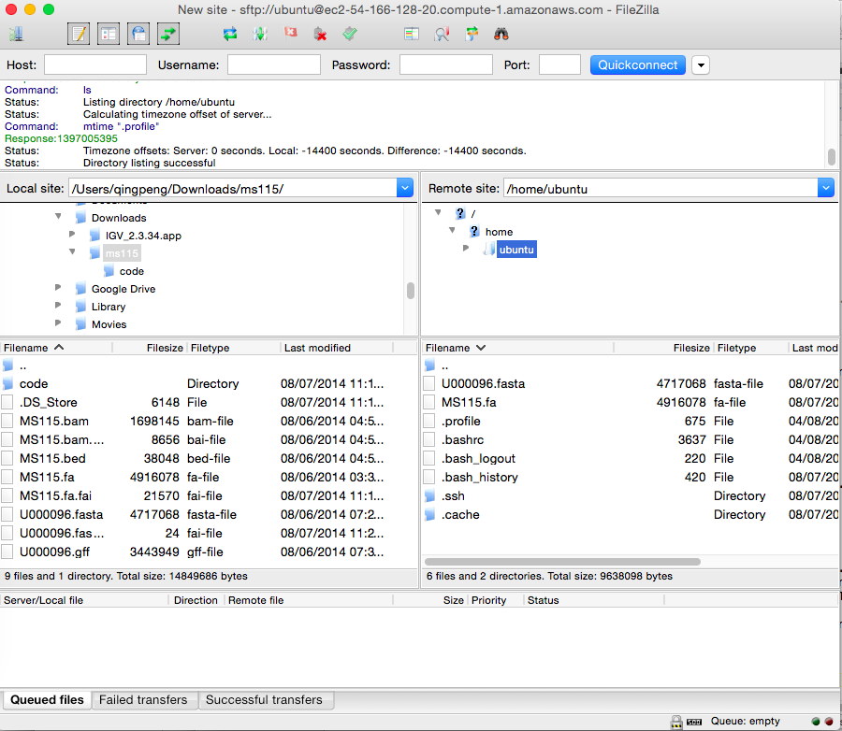](http://angus.readthedocs.io/en/2014/_images/final_filezilla.png)